Muel ESB is a lightweight Java-Based Enterprise Service Bus

Integration:- The process of making Communication/ Data Transfer between multiple systems is nothing but the Integration.

Different ways of Making Integration.

SOAP(Simple Object Access Protocol):- It will be understand only XML.

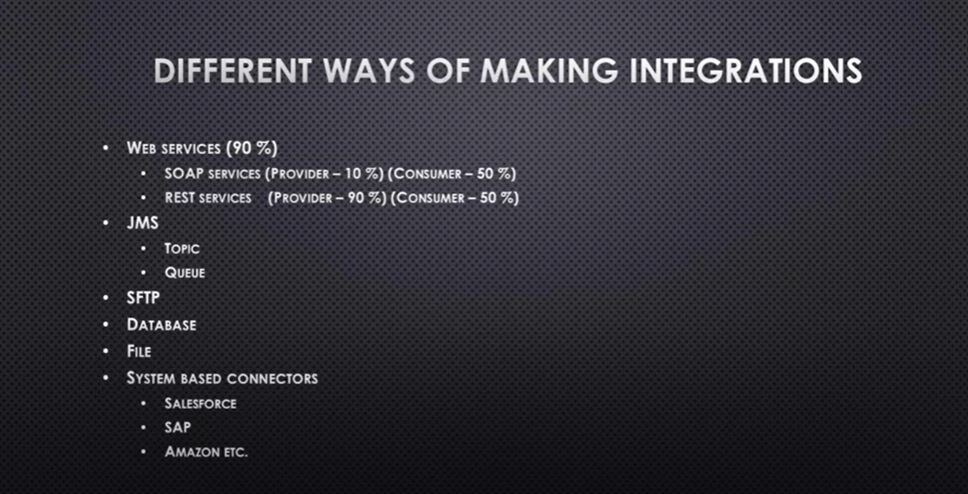

Web Services:-

SOAP

REST

JMS:- Java Message Service

If we send a message to individual person it will go to Queue and If we send a message to group it will go to the TOPIC.

SFTP:- They connected to my location and take the info whatever require is called SFTP One Drive is the best example. Simple File Transfer Protocol.

DATABASE:-

**Training Plan:-**

Core concepts:-

1. Development
2. Design API
3. Deployment
4. API Management

Advance Concepts:-

1. Development
2. Devops with Mule
3. MULE Interview Questions
4. MULE Certification Preparation
5. Upcoming Concepts
6. Training Plan Excel

**Session 2:-**

**ESB Vs Point to Point Integration:-**

What is point to point Integration:- Two Systems will be integrated. I cant do integration at a time if I have more than 2 systems.

Once System A changes the URL in future remaining B,C,D systems need to do changes. The number of Integrations are increased proportionally if we increase the System.

